1. sudo apt-get install openssh-server

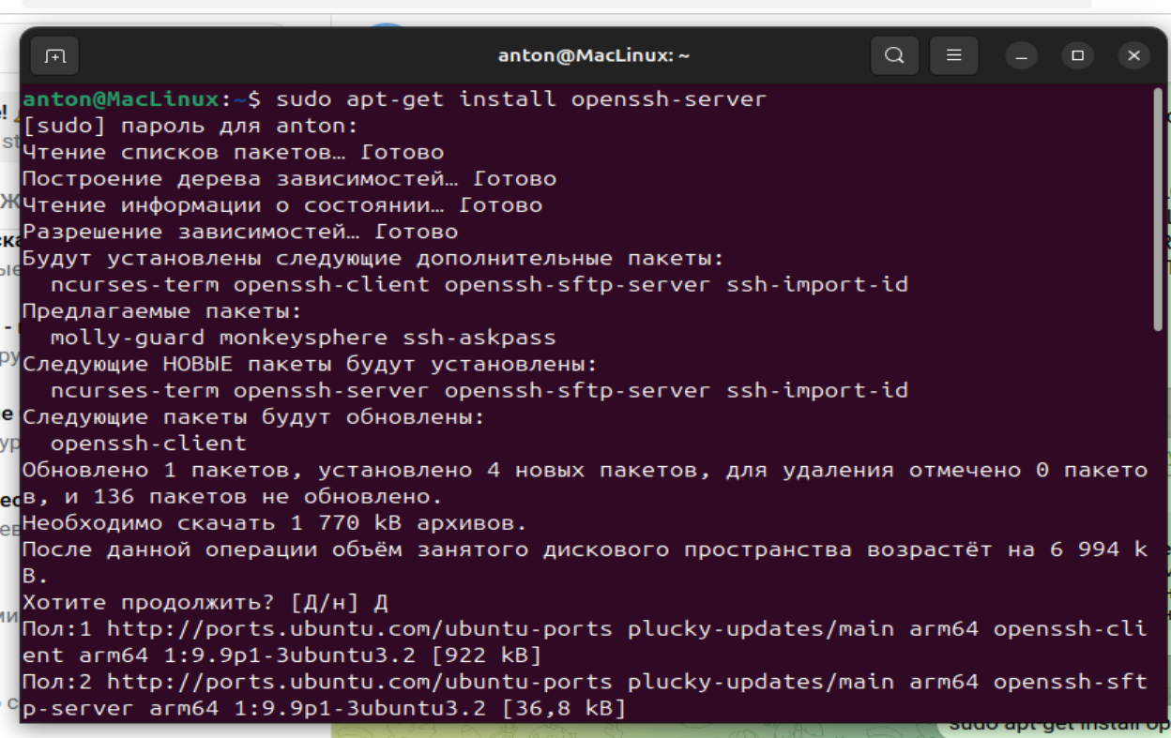

2. sudo systemctl status ssh

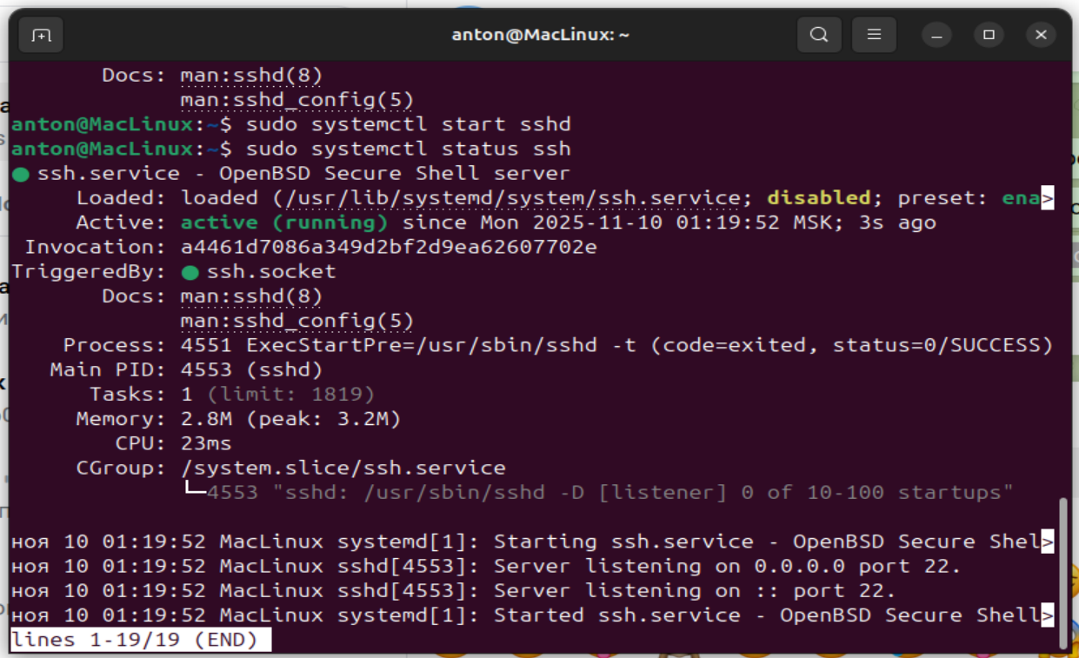

3. ssh anton@127.0.0.1 -p 2222

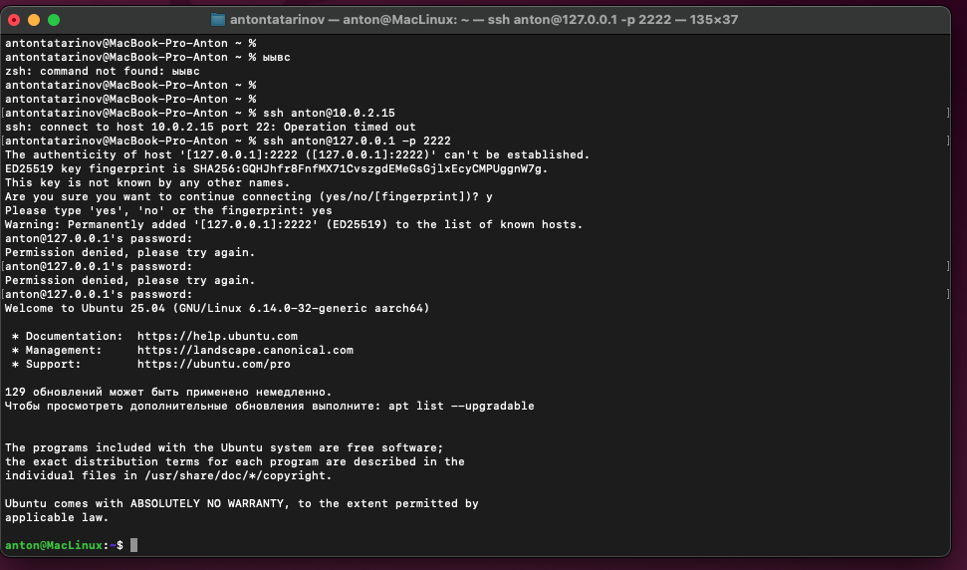

4. scp -P 2222 "/Users/antontatarinov/Arhive.zip" anton@127.0.0.1:/home/anton/

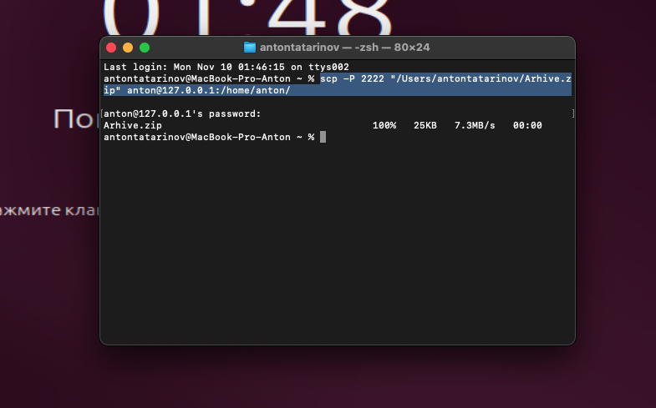

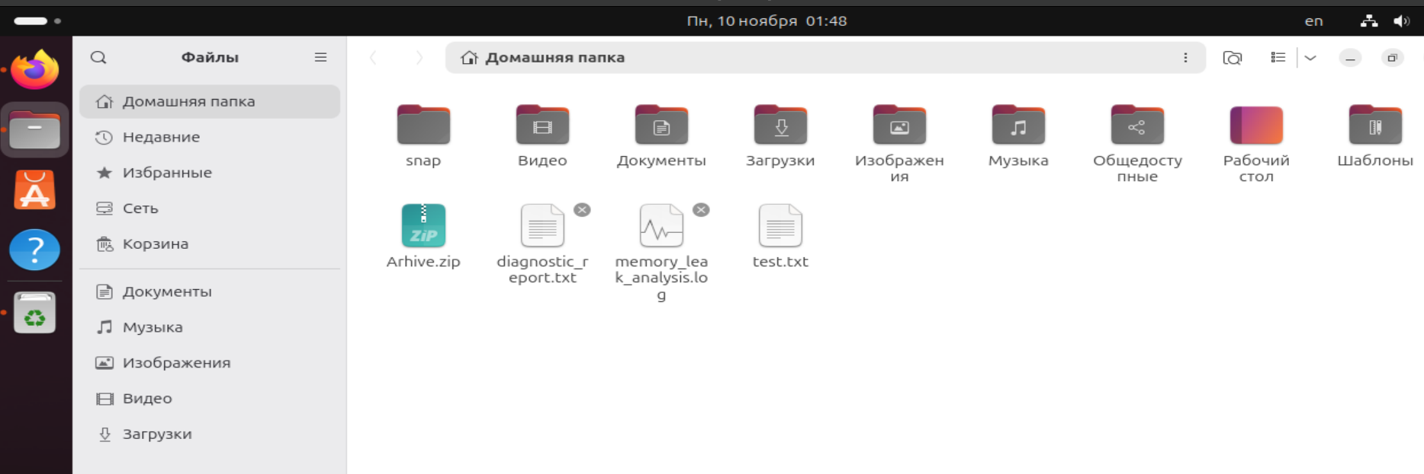

5. ssh-keygen

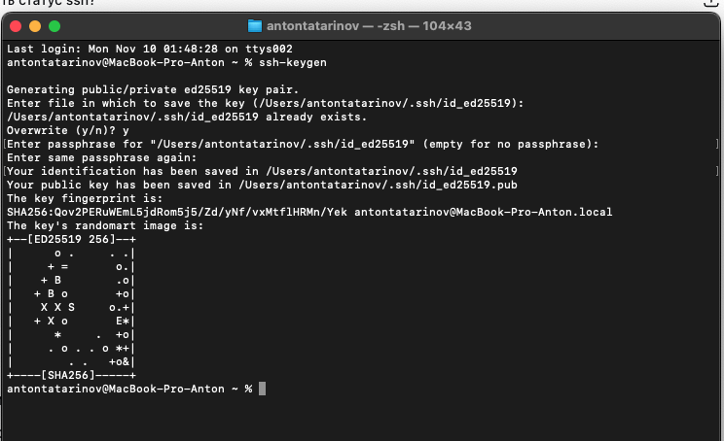

6. ssh-copy-id -p 2222 anton@127.0.0.1

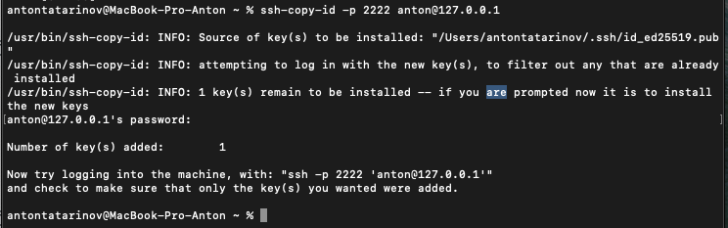

7. ssh -p 2222 anton@127.0.0.1

